**COMP1350 2021 – ASSIGNMENT ONE**

|  |
| --- |
| **Student ID: 45188416**  **Student Name: Jai Carey**  **Tutor’s Name:**  **Sarahali Siddiqui**  **Class Number: 21** |

Task 1: EER Diagram

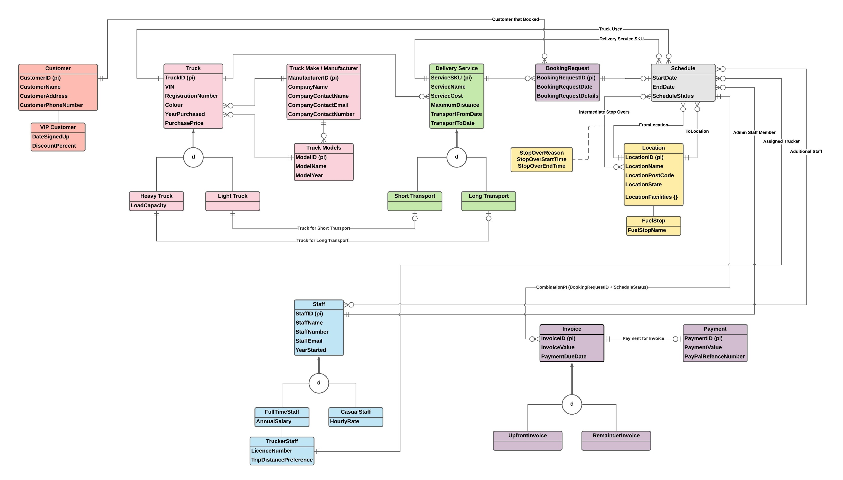

Assumptions, if any:

* Staff emails are also recorded
* The “make” and “manufacturer” of a truck are the same thing. Each “make” or “manufacturer” can produce many models of truck
* Stop over locations are categorised as a standard location. The facilities, name and address are all recorded as per normal
* Maximum of 1 truck per trip
* All trips are domestic / national – Meraki only operates within 1 country, transferring between trucks after flights or any similar situation is not something Meraki do

Task 2: Logical Transformation

**Step 1 - Strong Entities:**

* Customer (CustomerID (pk), CustomerName, CustomerAddress, CustomerPhoneNumber)
* Truck (TruckID (pk), VIN, RegistrationNumber, Colour, YearPurchased, PurchasePrice)
* Truck Make / Manufacturer (ManufacturerID (pk), CompanyName, CompanyContactName, CompanyContactEmail, CompanyContactNumber)
* Truck Model (ModelID (pk), ModelName, ModelYear)
* Delivery Service (ServiceSKU (pk), ServiceName, ServiceCost, MaximumDistance, TransportFromDate, TransportToDate)
* Booking Request (BookingRequestID (pk), BookingRequestDate, BookingRequestDetails)
* Staff (StaffID (pk), StaffName, StaffNumber, StaffEmail, YearStarted)
* Invoice (InvoiceID (pk), InvoiceValue, PaymentDueDate)
* Payment (PaymentID (pk), PaymentValue, PayPalReferenceNumber)

**Step 2 - Weak Entities:**

* This diagram has no weak entities

**Step 3 – One-one relationships:**

* Long Transport (ServiceSKU (pk), TruckID (fk))
* Short Transport (ServiceSKU (pk), TruckID (fk))
* Payment (PaymentID (pk), PaymentValue, PayPalReferenceNumber, InvoiceID (fk))

**Step 4 – One-many relationships:**

* Booking Request (BookingRequestID (pk), BookingRequestDate, BookingRequestDetails, CustomerID (fk))
* Delivery Service (ServiceSKU (pk), ServiceName, ServiceCost, MaximumDistance, TransportFromDate, TransportToDate, TruckID (fk))
* Truck (TruckID (pk), VIN, RegistrationNumber, Colour, YearPurchased, PurchasePrice, ManufacturerID (fk))
* Truck (TruckID (pk), VIN, RegistrationNumber, Colour, YearPurchased, PurchasePrice, ModelID (fk))
* Truck Models (ModelID (pk), ModelName, ModelYear, ManufacturerID (fk))
* Booking Request (BookingRequestID (pk), BookingRequestDate, BookingRequestDetails, ServiceSKU (fk))

**Step 5 – Many-many relationships:**

* This diagram has no many to many relationships, only ternary relationships

**Step 6 – Multi-valued attributes:**

* LocationFacilities (LocationID (pk), FacilityID (pk))

**Step 7 – Associative entity / Ternary relationship:**

* Schedule (StartDate, EndDate, ScheduleStatus, TruckID (fk), BookingRequestID (fk), ServiceSKU (fk), FromLocation (LocationID - fk), ToLocation (LocationID - fk), StopOverLocations (List of LocationIDs - fk), AdminStaffMember (StaffID – (fk), AssignedTrucker (StaffID – (fk), AdditionalStaffMember (List of StaffIDs – (fk))

**Step 8a – Multiple relations – Superclass and subclasses:**

* Heavy Truck (HTruckID (pk, fk), LoadCapacity)
* Light Truck (LTruckID (pk, fk))
* Short Transport (STServiceSKU (pk, fk))
* Long Transport (LTServiceSKU (pk, fk))
* FullTimeStaff (FTStaffID (pk, fk), AnnualSalary)
* CasualStaff (CStaffID (pk, fk), HourlyRate)
* TruckerStaff (TRStaffID (pk, fk), AnnualSalary, LicenseNumber, TripDistancePreference)
* VIP Customer (VIPCustomerID (pk, fk), DateSignedUp, DiscountPercent)
* FuelStop (FSLocationID (pk, fk), FuelStopName)
* UpfrontInvoice (UFInvoiceID (pk, fk))
* RemainderInvoice (RInvoiceID (pk, fk))

Repeat Steps 2-7:

**Step 1 - Strong Entities:** No Changes

**Step 2 - Weak Entities:**

* Schedule (**BookingRequestID (pk, fk), ScheduleStatus (pk),** StartDate, EndDate, ServiceSku (fk), TruckID (fk), FromLocationID (fk), ToLocationID (fk), IntermediateStopOverLocations (fk), AdminStaffID (fk), TStaffID (fk), AdditionalStaffID (fk))

**Step 3 – One-one relationships:** No Changes

**Step 4 – One-many relationships :** No Changes

**Step 5 – Many-many relationships:** No Changes

**Step 6 – Multi-valued attributes:** No Changes

**Step 7 – Associative entity / Ternary relationship:** No Changes

Final Table List:

* Customer (**CustomerID (pk, fk)**, CustomerName, CustomerAddress, CustomerPhoneNumber)
* VIP Customer (**VIPCustomerID (pk, fk)**, DateSignedUp, DiscountPercent)
* Truck (**TruckID (pk, fk)**, VIN, RegistrationNumber, Colour, YearPurchased, PurchasePrice, **ManufacturerID (fk)**, **ModelID (fk)**)
* Truck Make / Manufacturer (**ManufacturerID (pk, fk)**, CompanyName, CompanyContactName, CompanyContactEmail, CompanyContactNumber)
* Truck Model (**ModelID (pk, fk)**, ModelName, ModelYear, **ManufacturerID (fk)**)
* Heavy Truck (**HTruckID (pk, fk)**, LoadCapacity)
* Light Truck (**LTruckID (pk, fk)**)
* Delivery Service (**ServiceSKU (pk, fk)**, ServiceName, ServiceCost, MaximumDistance, TransportFromDate, TransportToDate, **TruckID (fk)**)
* Short Transport (**STServiceSKU (pk, fk)**, **LTruckID (fk)**)
* Long Transport (**LTServiceSKU (pk, fk)**, **HTruckID (fk)**))
* BookingRequest (**BookingRequestID (pk, fk)**, BookingRequestDate, BookingRequestDetails, **ServiceSKU (fk)**, **CustomerID (fk)**)
* Schedule (**BookingRequestID (pk, fk), ScheduleStatus (pk),** StartDate, EndDate, **ServiceSku (fk)**, **TruckID (fk)**, **FromLocationID (fk)**, **ToLocationID (fk)**, **IntermediateStopOverLocations (fk)**, **AdminStaffID (fk)**, **TStaffID (fk)**, **AdditionalStaffID (fk)**)
* Location (**LocationID (pk, fk)**, LocationName, LocationPostCode, LocationState, LocationFacilities)
* FuelStop (**FSLocationID (pk, fk)**, FuelStopName)
* IntermediateStopOvers (**LocationID (pk, fk)**, LocationName, LocationPostCode, LocationState, LocationFacilites, StopOverReason, StopOverStartTime, StopOverEndTime)
* Staff (**StaffID (pk, fk)**, StaffName, StaffNumber, StaffEmail, YearStarted)
* FullTimeStaff (**FTStaffID (pk, fk)**, AnnualSalary)
* CasualStaff (**CStaffID (pk, fk)**, HourlyRate)
* TruckerStaff (**TRStaffID (pk, fk)**, AnnualSalary, LicenseNumber, TripDistancePreference)
* Invoice (**InvoiceID (pk, fk)**, InvoiceValue, PaymentDueDate, **ScheduleID (BookingRequestID + ScheduleStatus) (fk)**)
* UpfrontInvoice (**UFInvoiceID (pk, fk)**)
* RemainderInvoice (**RInvoiceID (pk, fk)**)
* Payment (**PaymentID (pk, fk)**, PaymentValue, PayPalReferenceNumber, **InvoiceID (fk)**)